Magnet or Sticky? A Stack Overflow Tag-by-Tag Typology

*Abstract*—Stack Overflow (SO) is one of the most popular question and answer website among software developers. There are many tags in Stack Overflow. If you ask about Python and tag that post with ”Python”, people interested in Python can follow that tag and see your post. Many questions and answers are received every day for Stack Overflow. We explored how their interest shifted from how they use tags. We classified tags into four types: (1) attractive, (2) stagnant, (3) fluctuating, and (4) terminal based on magnet values and sticky values. we arelyzeze the Stack Overflow dataset provided by Sebastian Baltes reference here - SOTorrent: Reconstructing and Analyzing the Evolution of Stack Overflow Posts. We anlyze the data from table ”Posts” which includes about 42 million posts from Stack overflow and table ”Users” where there are about 9 million rows of user information. Analysis of stack overflow revealed that: (1) There were some historical events in IT such as the launch of new tools and the termination of services when there were characteristics in the transition of magnet value and sticky value. (2) The types of tags that are classified do not change much. [1].

*Index Terms*—magnet, sticky, tag, user migration, OSS census

I. INTRODUCTION

Pew Research Center [2], an organization that studies prob- lems in the United States and the world, investigated society and population using US tax survey data. States that have a high percentage of people migrating from the outside are defined as *magnet states* and states where the high proportion of the population who continues to live in the same state since birth are defined as *sticky states*. For example, 86% of Nevada’s population migrated from other states so Nevada state is quite *magnet*. Through such a survey, you can find the tendency how American citizens move.

For many developers, it is important to know the changes in the interests of other developers because popularity among many people should have advantages. Developers always want to develop with convenient and easy-to-use tools. To make a project better, excellent developers need to be interested in the project over the long term.

According to the definition of magnet and sticky to be defined later, we classified tags used for stack overflow into magnet tags and sticky tags. In addition we define attagnifying strong magnetic and strong sticky *attractive*, strong magnet weak sticky *stagnant*, weak magnet strong sticky *fluctuating*, weak magnet defines a weak sticky *terminal*. By classifying like this, we analyzed what we know from the popularity of tags. We examined tags’ magnets and sticky values by classifying them as tags *programming language*, *framework*,

*environment*, *OS* and researching theme by theme. We also compared the news and history of the IT industry, if there are characteristic changes in magnet values and sticky values, we examined why it was like that. We addressed the following two research questions:

(RQ1) What are typical values of magnet and sticky in Stack Overflow?

In many cases, the sticky value tended to be higher than the magnet value. In addition, the decrease rate was higher for the magnet value than for the sticky value. If it is easy to use and convenient like the .NET Framework, the magnet value and the sticky value are high.

(RQ2) How do magnet and sticky values change over the time?

We can identify which tags are obsolete. When the tags move quadrant, we find that something happen.

II. DEFINITION OF MAGNET AND STICKY

This section describes how we measure the appeal and adhesion of users on different topics on Stack Overflow in this study, we use the Magnet and Sticky metrics defined by the Pew Research Center for illustrating the migratory trends of citizens in the United States.

The Pew Research Center report defines magnet states as those states where a large proportion of adults who live there have moved from another state. Thus, the magnet metric for a state is the proportion of adult residents of a state who were not born in the state. Furthermore, the report also defines sticky states as those states where a large proportion of adults who were born there continue to live there. Thus, the sticky metric for a state is the proportion of adult residents who were born in the state

These definitions are sound for a study of populations, where a single adult can only occupy one state at a time. However, the definition cannot be applied directly to the topics discussed by the users of Stack Overflow where a user can ask or answer questions in several topics at the same time. Therefore, we expand original definition to apply to topics in Stack Overflow as follows:

*Topics discussed in Stack Overflow*

Questions in Stack Overflow are composed of the content of the question, answers to the questions and comments [3], that are call Posts in the database of SOTorrent. Each question has one or more tags that separate the question into different topics. Simultaneously, posts in a question have their own

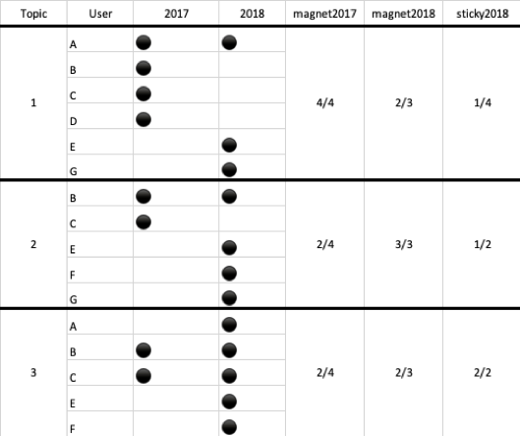

Fig. 1. Example of Magnet and Sticky values definition

creater (for the content of question, one is the questioner, and for the answer, one is the respondent) who is participant of the topics of the question. We also define the activity of asking or answering questions in some topic as discussion of the topic. For example, a classical question in Stack overflow has three tags like java, apache and linux which is asked by user A and answered by user B, and C, so A, B and C are participants of topic java, apache and linux.

Magnet Magnets are those that attract a large proportion of new users. Thus, we calculate the magnetism of a topic as the proportion of susers who ask or answer during the time period under research to all new users who registered their account at the year.

Sticky Sticky topics are those where a large proportion of the users will keep participating in discussion in the time period under research and the following. Thus, we calculate the stickiness of a topic as the proportion of the users who discuss within the topic in the time period under research to who have also discuss in the following time period.

Let us take the survey of magnet and sticky of some topics belong to a major category as an example. There are 6 questions (a, b, c, d, e, f) and 7 users (A, B, C, D, E, F, G), the Last Activity Date of question a, b, c is during 2017 and question d, e, f is during 2018. the register date of user A, B, C, D is during 2017 and the register date of user E, F, G is during 2018 [4].

Questions have different tags. We merge tags belonging to analogous subjects into one topic,for example tag ”python-2.7” and tag ”python-3.6” are merged into topic ”python”. So we get 3 topics in this case.

To calculate the magnet metric, we observe that there are four new users who register his/her account in 2017 (A, B, C and D), and all of them discuss in topic 1, while two of them (B, C) participate in the discussion of topic 2 and 3. In this case, Magnet value of topic 1 in 2017 is 4/4, topic 2 is 2/4 and topic 3 is 2/4.

To calculate the sticky metric, on topic 1, there are three users participate in the discussion in 2017 (A, B and C) but only one of them also participate in the discussion in 2018 (A). Hence, the sticky value of project 1 is 1/4. on topic 2, there are 2 users participate in the discussion in 2017 (B and C) but only one of them also participate in the discussion in 2018 (B). Even though new users E F G participate in the discussion in 2018, we still calculate the value of sticky as 1/2. For the same reason, the sticky of topic 3 is 2/2 in 2018

III. DATASET

In this paper, we anlyze the Stack Overflow dataset provided by Sebastian Balte [5] called SOTorrent.

SOTorrent is“an open dataset based on the official SO data dump. SOTorrent provides access to the version history of SO content at the level of whole posts and individual text or code blocks. It connects SO posts to other platforms by aggregating URLs from text blocks and by collecting references from GitHub files to SO posts. ”

The dataset includes 20 different table which store not only data from official SO data dump but also data extracted from original data dump.

However, in this paper, we only anlyze the data from table ”Posts” which includes about 42 million posts from Stack overflow and table ”Users” where there are about 9 million rows of user information. And we pay attation to user, tag and time informaiton of questions.

In this paper, we consider a user to be one who ask or answer questions in Stack Overflow. Those who comment or like/unlike on questions or answers are not counted in the statistics.

IV. STUDY RESULTS

We set research results and faced two questions against these results. We discuss the questions based on the results.

(RQ1) What are typical values of magnet and sticky in OSS?

We have calculated magnet and sticky values as defined in section 2. And we plotted the magnet value on the vertical axis and the sticky value on the horizontal axis. We classified the plotted points into 4 quadrants.

Attractive: Tag with high magnet and sticky value. By knowing attractive tags, we can find out what the developers are interested in.  
Fluctuating: Tagwith high magnet and low sticky value. This tag attracts people but it is short-term. Excellent developers will not continue to be interested.

Stagnant: Tag with low magnet and high sticky value. These tags are difficult to attract new users, but maintain existing users.  
Terminal: Tag with Low magnet and low sticky value. This tag can neither attract new users’ developers nor keep them interested.

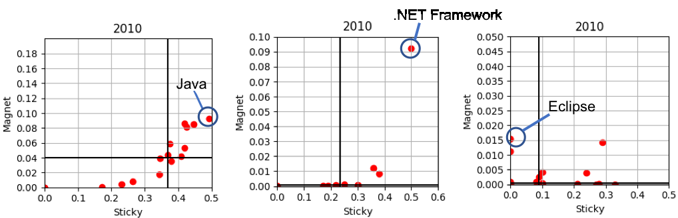

Fig. 2. Distribution of Magnet and Sticky values in Programing Language, Framework and Environment

In this paper, the median of magnet and sticky values for each year is used for the threshold of the quadrant because the median value is not much affected by outliers. As we showed the sticky value definition in section 2, the sticky value depends on the number of tag users in that year and the following year. So in order to answer RQ1, we got 9 years’ worth of sticky value from the information on the number of tag users from 2009 to 2018. The sticky value must depend on the number of new tag users but if the number of new tag users in the target year is too low, the sticky value will be too small. Therefore, in order to remove noise, we decided thresholds for each topics and when the magnet and sticky value is less than the threshold value, it is set to 0.

Quantitive results: Figure 2 shows a quadrant plot of the magnet and sticky values of the 2010 framework, program- ming language, environmental tag from the left. From the values on the vertical axis and the horizontal axis in Figure 2, you can see that the value of magnet is lower than the value of sticky. In other words, it is more common that the tag used in the overflow is not a magnet but a tag. This is also in the investigation of the Pew Research Center mentioned earlier. The engine tends to continue to develop using the tags of the same content so that those who have continued to live on the same land rather than tranquil are easy to pass away.

Manual analysis: From Figure 2, .net is a high magnet and sticky value. It can be said that it is very good to be a high magnet and sticky value. The .NET Framework was announced to Microsoft in November 2006. This is because the magnet value of .NET that was on the net is high because beginner engines can develop somewhat advanced software. Are there many reasons why the .NET sticky value is high reasons most conveniently? It is the foundation system for building applications. It is from. Java has long been popular and attractive as it is one of the most famous programming languages in the world. Eclipse attracted people in 2010, so the magnet value is high. There was no big change in eclipse in 2010, I guessed that the popularity of the word eclipse soared in the Google trend where the movie of TheTwilight Saga: Eclipse has been released in this year, so I am influencing it .

Table I. Average Quadrant Transition rate

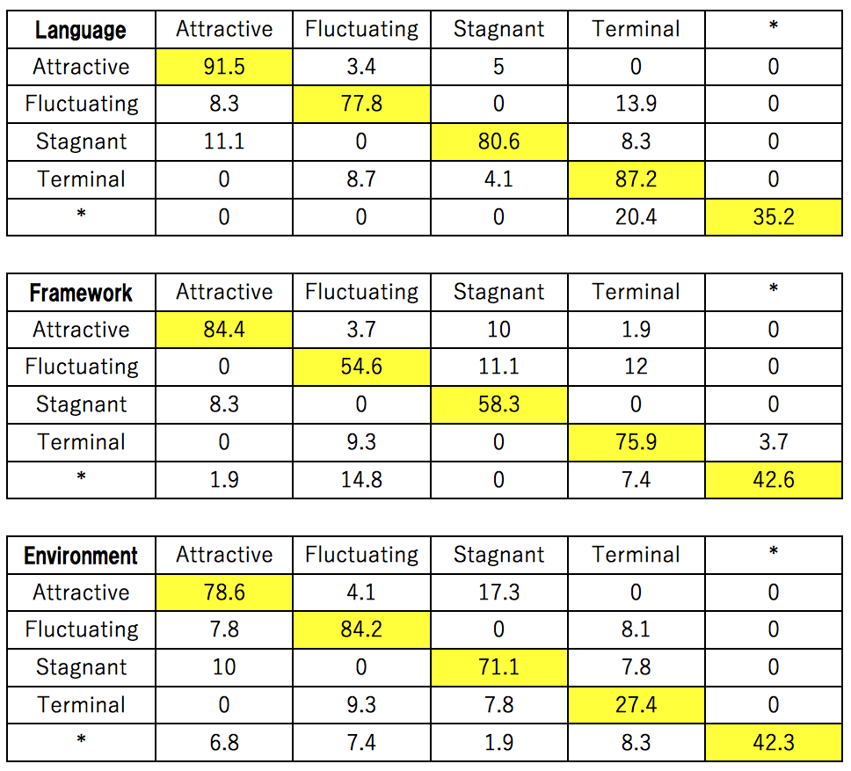

*Tags with high magnet value are easy to use even for beginners. Especially magnet tags like .NET are relatively easy to use so tags famous for old like tag like java used a lot for beginners etc are attractive both magnet value and sticky value are high. Also from the eclipse example, the trend of tags can often be affected by something unrelated to itself.*

(RQ2) How do magnet and sticky values change over time?

Approach: We investigated how the tags move with time over

the quadrants.  
Quantitive results: Table I shows the proportion that the vertical axis is in that quadrant for some years up to 2009- 2018, the horizontal axis is that year old. From the table, it can be seen that the ratio of tags that do not move the quadrants from the previous year to the following year is the highest in any field of programming language, framework,

environment. Since it has not changed from any quadrant to \*, once popularity comes up to a certain degree, the users of that tag never decrease extremely.

Manual analysis: Table II shows the transition of the quadrant of each tag in the programming language. From this table, tags learn how to transpose quadrants. Table II shows that programming language tags often stay in the same quadrant. It turns out that tags frequently change between Attractive and Stagnant, Terminal and Flactuating.

2. Under their respective major categories, the most popular topics are still very popular after ten years, and only a small number of languages or frameworks can stand out and become one of the most popular topics.

3. This research can provide some reference for enterprises to choose their own main technology stack, and can also be used as a reference for computer science students to learn new technologies, because it (1) predicts the trend of computer technology in the next few years, (2) points out which technologies are easier to access and the questions can be easier to get answers to.

REFERENCES

1. [1]  K. Yamashita, S. McIntosh, Y. Kamei, and N. Ubayashi, “Magnet or sticky? an oss project-by-project typology,” in *Proceedings of the 11th working conference on mining software repositories*. ACM, 2014, pp. 344–347.
2. [2]  C. for Community and C. E. Economic Development University of Wisconsin-Extension, “Community & economic development update,” 2011, https://myemail.constantcontact.com/News- from-the-Center-for-Community—Economic- Development.html?soid=1104293309477&aid=FnOfZtbhFgo.
3. [3]  X.LiuandH.Zhong,“Miningstackoverflowforprogramrepair,”in*2018 IEEE 25th International Conference on Software Analysis, Evolution and Reengineering (SANER)*. IEEE, 2018, pp. 118–129.
4. [4]  K. Yamashita, Y. Kamei, S. McIntosh, A. E. Hassan, and N. Ubayashi, “Magnet or sticky? measuring project characteristics from the perspective of developer attraction and retention,” *Journal of Information Processing*, vol. 24, no. 2, pp. 339–348, 2016.
5. [5]  S. Baltes, L. Dumani, C. Treude, and S. Diehl, “The evolution of stack overflow posts: Reconstruction and analysis,” *arXiv preprint arXiv:1811.00804*, 2018.

Table II. Quadrant Transition of Programing Language 2009 - 2018

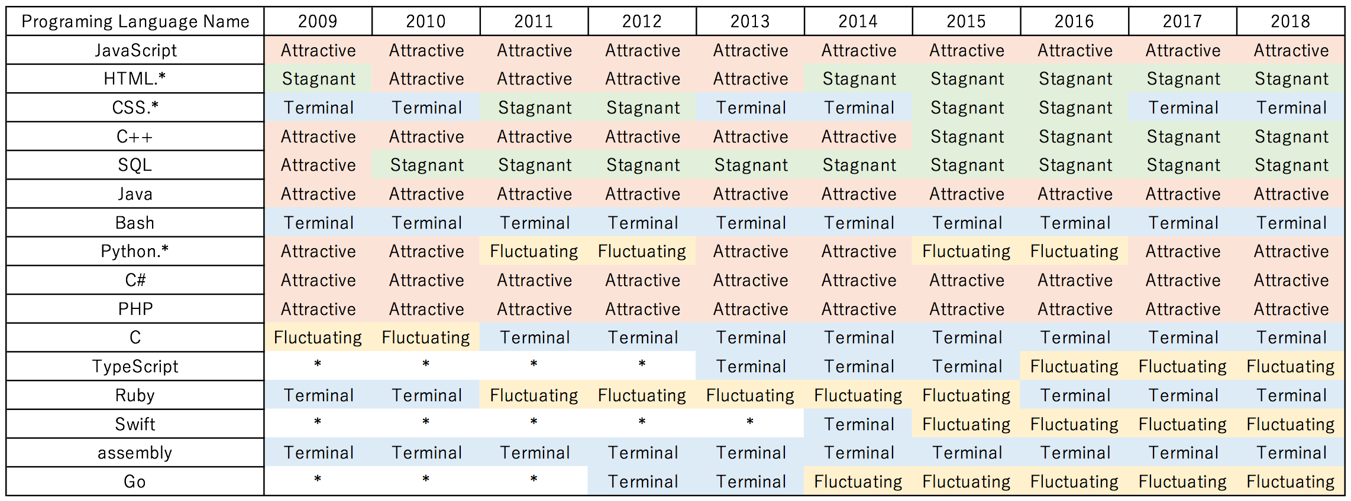

*As a result of investigating from 2009 to 2018, in the programming language, the average transition from Attractive to Attractive was 91.5%, the transition from Fluctuating to Fluctuating was 77.8%, the change from Stagnant to Stagnant was 80.6%, and the change from Terminal to Terminal was 87.2%. Regardless of the kind of tag, it turned out that the classification of tags was difficult to change.*v

V. CONCLUSIONS

Whether it’s a programming language or a program frame- work or an operating system, keeping the community alive and attracting more people to participate in discussions is critical to its development. Especially on the stack overflow, the world’s largest program Q&A platform, having more questions and answers on a topic means that customers of the product are more likely to solve their own problems, which is even more tedious than that developers rack their brains to write a lengthy development document or Q&A This paper applied the magnet and sticky population concepts to a set of topics in Stack Overflow. We find that:

1. The number of topics that people participate in is exploding with the development and popularity of computer technology. Even the most popular themes can’t attract the high percentage of people involved in the discussion like what they did ten years ago.